***AIDS MICROPROCESSOR LAB S21 BATCH (2023-24)***

***Experiment 5(a) Title: Assembly language programming to perform code conversion ASCII to BCD using software tool TASM 1.4***

***Name of student: Meet Raut Class Roll Number: 2201084***

***Date of Performance: 18/03/2024***

***Batch: S2-1 Timing: 3:00-5:00 Date of Submission: 18/03/2024***

***Assembly language code***

*DATA_SEG SEGMENT*

*ASCIINUM DW 3137H*

*BCDNUM DW 0*

*DATA_SEG ENDS*

*CODE_SEG SEGMENT*

*ASSUME CS:CODE_SEG , DS:DATA_SEG , ES:DATA_SEG*

*START :*

*MOV AX,DATA_SEG #INTIALISE THE DATA SEGMENT REGISTER*

*MOV DS,AX*

*MOV AX,ASCIINUM #STORE ASCII NUMBER IN AX*

*AND AX,0F0FH #AND OPERATE BETWEEN ASCII NUMBER AND OFOFH*

*MOV BCDNUM,AX #MOVE THE RESULT OF AND IN AX INTO BCDIUM*

*MOV AH,4CH #REQUEST TO TERMINATE*

*INT 21H #EXIT TO DOS*

*CODE_SEG ENDS*

*END START*

*Result :*

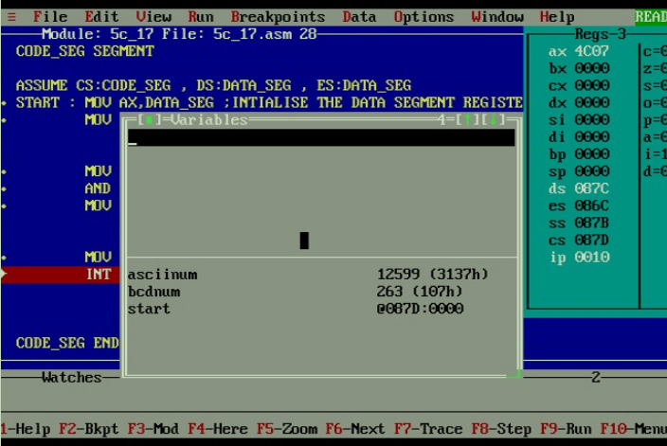

***Experiment 5(b) Title: Assembly language programming to perform code conversion BCD to ASCII using software tool TASM 1.4***

***Name of student: Meet Raut Class Roll Number: 2201084***

***Date of Performance: 18/03/2024***

***Batch: S2-1 Timing: 3:00-5:00 Date of Submission: 18/03/2024***

***Assembly language code***

*DATA_SEG SEGMENT*

*ASCIINUM DW 0*

*BCDNUM DB 24H*

*DATA_SEG ENDS*

*CODE_SEG SEGMENT*

*ASSUME CS:CODE_SEG , DS:DATA_SEG , ES:DATA_SEG*

*START :*

*MOV AX,DATA_SEG #INTIALISE THE DATA SEGMENT REGISTER*

*MOV DS,AX*

*MOV AH,BCDNUM #MOV PACKED BCD NUMBER INTO AH,AL*

*MOV AL,BCDNUM*

*AND AH,0F0H #LOGICAL AND OPERATION BETWEEN AH AND OPEN*

*SHR AH,4 #RIGHT SHIFT AH BY 4 BITS*

*AND AL,0FH #AND OPERATION BETWEEN AL AND F0H*

*OR AX,3030H #LOGICAL OR OPERATION BETWEEN AX AND 3030H*

*MOV ASCIINUM,AX #MOVE AX IN ASCIINUM*

*MOV AH,4CH # REQUEST TO TERMINATE*

*INT 21H #EXIT TO DOS*

*CODE_SEG ENDS*

*END START*

*Result :*

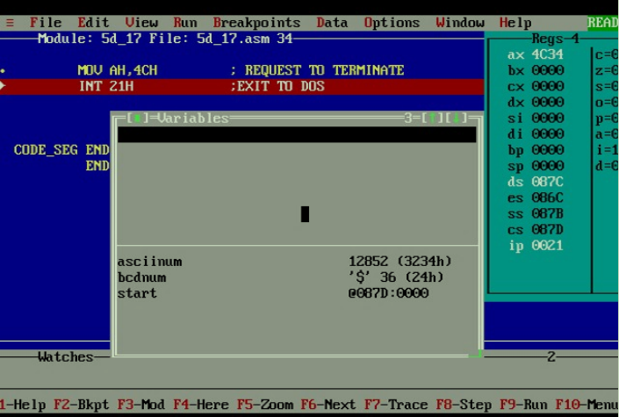

***CONCLUSION: LO 2, LO 3 mapped.***

***---------------------------------*****************************-----------------------------------***